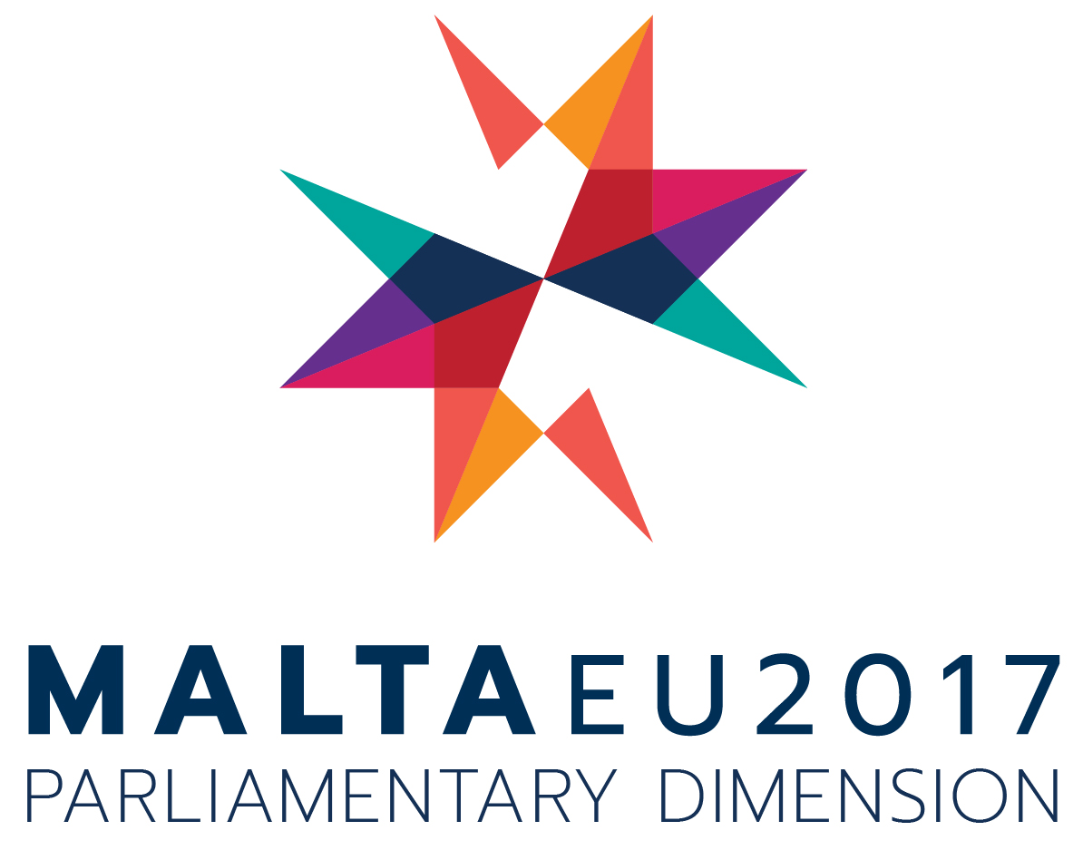

Questionnaire for the 27th
Bi-annual Report of COSAC

PARLIAMENT/CHAMBER AND CONTACT DETAILS

Please enter the name of your Parliament/Chamber and your contact details.

CHAPTER 1: SCRUTINY OF GOVERNMENT BY NATIONAL PARLIAMENTS OF EU PROPOSALS, REPORTS AND IMPLEMENTATION OF EU LAW

SECTION A: SCRUTINY OF EU PROPOSALS

- Is the European Affairs Committee the only Committee responsible for the scrutiny of EU proposals?
Yes €
No €

If the answer is No please tick where applicable:
- The European Affairs Committee is the Committee responsible for the scrutiny of EU proposals but can also delegate this responsibility to other sectoral committees for further scrutiny.
- The European Affairs Committee acts only as a filtering committee.
- EU proposals are scrutinised by sectoral committees according to policy areas.
- Other, please specify

- National scrutiny systems vary inevitably according to the national context and to constitutional provisions in place. At which stage is your Parliament/Chamber active?
- The Parliament/Chamber scrutinises government’s position only on the original proposal of the EU institutions.
- The Parliament/Chamber scrutinises government’s position throughout the whole EU legislative process, on all EU proposals.
- The Parliament/Chamber selects those EU proposals that are deemed important or sensitive and scrutinises the government’s position throughout the EU legislative process.
- Other, please specify

- What is the relationship between your Parliament/Chamber and the national government with regard to scrutiny of EU proposals? You may choose more than one:
- Government sends explanatory memoranda outlining its position to the Parliament/Chamber on all EU proposals.
- Government sends explanatory memoranda outlining its position to the Parliament/Chamber on selected EU proposals.
- Government needs a parliamentary mandate before taking a position in the Council.
- Government briefs Parliament/Chamber before taking a position in the Council.
- Government reports to the Parliament/Chamber about the positions taken in the Council.
- Other, please specify

- When the Parliament/Chamber is carrying out subsidiarity and proportionality checks in terms of Protocol 2 of the Treaty on the Functioning of the European Union, does the Parliament/Chamber receive the government’s position on the draft legislative act within the 8-week deadline?
- Always
- Sometimes
- Upon request by the Parliament/Chamber
- Rarely
- Never
- Not applicable

- Is the responsible Minister obliged to appear before the relevant committee on issues related to scrutiny of the government position on EU proposals?
Yes €
No €

If the answer is Yes please specify where this obligation arises from? (Max. 500 characters)

- How frequently does the European Affairs Committee or any other relevant sectoral committee meet to carry out scrutiny of the Government position on EU proposals?
- Every week
- Every fortnight
- Every month
- Other, please specify

- Is the frequency with which the European Affairs Committee or any other relevant sectoral committee meets to scrutinise Government’s position on EU proposals governed by any legal text?
Yes €
No €

SECTION B: SCRUTINY OF EU REPORTS AND IMPLEMENTATION OF EU LAW

- Does your Parliament/Chamber carry out the evaluation of the existing EU legislation and submit its reports to your Parliament/Chamber?
Yes €
No €

If yes, how often does your Parliament/Chamber scrutinise these reports?
- Always
- Regularly
- Occasionally
- Never
- Not applicable

- How often does your Parliament/Chamber scrutinise the government position on the reports of the European Commission evaluating existing EU legislation
- Always
- Regularly
- Occasionally
- Never
- Not applicable

- a) The evaluation reports of the European Commission on the implementation of EU laws are sufficient tools for national Parliaments to scrutinise their Government on the implementation of EU law.
- Strongly agree
- Agree
- Neither agree nor disagree
- Disagree
- Strongly disagree

b) The evaluation reports of the European Commission on the implementation of EU laws go into enough detail on the effect on each and every Member State.
- Strongly agree
- Agree
- Neither agree nor disagree
- Disagree
- Strongly disagree

c) Parliaments should have access to additional information other than the implementation reports published by the European Commission.
- Strongly agree
- Agree
- Neither agree nor disagree
- Disagree
- Strongly disagree

- Which tool, if any does your Parliament/Chamber use to monitor or scrutinise Government on the implementation of EU law? You may choose more than one:
- Members may raise a debate in the plenary
- Members may raise a debate in the relevant committee
- Members may compile a report on their own initiative
- Other, please specify

- The 23rd Bi-annual Report of COSAC has shown that national Parliaments have a limited role if any, when it comes to the transposition of EU law. Should national Parliaments have a greater role in better monitoring the implementation and transposition of EU law?
Yes €
No €
If the answer is Yes please explain briefly in what way (Max. 500 characters)

- If you wish to provide any additional information on Chapter 1, please do so below:

CHAPTER 2: THE OUTCOME OF THE UK REFERENDUM AND THE FUTURE OF THE EUROPEAN UNION

SECTION A: THE UK REFERENDUM AND NATIONAL PARLIAMENTS

- Has your Parliament/Chamber discussed the effects of the outcome of the UK referendum on national policies? You may choose more than one:
- Yes, the debate was carried out in the Plenary.
- Yes, the debate was carried out in the committee responsible for European Affairs.
- Yes, a special committee was set up for this purpose.
- No, it is the intention to hold the debate once Article 50 is triggered.
- No, and there is no intention to do so.
- Other, please specify

- Has your Parliament/Chamber discussed the effects of the outcome of the UK Referendum on the future of the European Union? You may choose more than one:
- Yes, the debate was carried out in the Plenary.
- Yes, the debate was carried out in the committee responsible for European Affairs.
- Yes, a special committee was set up for this purpose.
- No, it is the intention to hold the debate once Article 50 is triggered.
- No, and there is no intention to do so.
- Other, please specify

- Has your Parliament issued a Resolution on Brexit?
Yes €
No €
Intends to do so €
Does not intend to do so €

- Should the UK officially trigger Article 50, developments on the negotiating process should feature in COSAC meetings.
- Strongly agree
- Agree
- Neither agree nor disagree
- Disagree
- Strongly disagree

- With regard to the negotiating process concerning the exit of the UK from the European Union, please tick where applicable:

 | Yes | No | No opinion
National Parliaments should receive regular updates from their governments on the progress of the negotiations
National Parliaments should receive updated reports from the negotiating team on the progress of the negotiations.
National Parliaments should be given the opportunity to ask questions and obtain further clarifications from the negotiating team on the progress of the negotiations.
A contact person from the negotiating team should be appointed to liaise directly with national Parliaments on issues relating to the negotiating process.
Parliaments and the European Commission should come together and regularly discuss the progress of the negotiating process.

- The European Parliament Brexit negotiator Mr Guy Verhofstadt stated that “any future relationship between Britain and the EU cannot infringe on the four freedoms”.

- Have discussions taken place on the possible impact that the deal with the UK could have on the four freedoms?
Yes €
No €

If the answer is Yes, has this discussion been carried out in: (Please tick where applicable)
- Plenary
- Committee
- Other, please specify

- What was the outcome of these discussions? (Max of 500 characters)

SECTION B: THE FUTURE OF THE EUROPEAN UNION

- How can national Parliaments further strengthen and promote the four freedoms? You may choose more than one:
- Discuss further the impact of the four freedoms on national economies.
- Conduct impact assessments on legislative packages, specifically keeping in mind the four freedoms.
- Propose ways in which the European Commission and other European Institutions ensure the development of the four freedoms.
- Discuss ways how national Parliaments could secure and promote the development of the four freedoms during COSAC meetings.
- No opinion

- Other, please specify

- The Commission Work Programme 2017 proposed a total of 10 priorities. Has your national Parliament discussed the Commission Work Programme 2017?
Yes €
No €
No, but intends to do so €

If the answer is Yes, where did the discussion take place? Please tick as applicable:
- In the Plenary
- At Committee level
- Other, please specify

- The 10 priorities identified by the Commission cover a wide range of topics. From the list hereunder, rate the priorities to reflect your Parliament/Chamber’s priorities:

Priority | Very  important | Important | Somewhat important | Not  important
A new Boost for Jobs, Growth and Investment
A connected Digital Single Market
A Resilient Energy Union with a forward-looking Climate Change Policy
A deeper and Fairer Internal Market with a Strengthened Industrial Base
A deeper and Fairer Economic and Monetary Union
Trade: A reasonable and Balanced Free Trade Agreement with the US
An Area of Justice and Fundamental Rights based on Mutual Trust
Towards a new policy on migration
A stronger global actor
A Union of Democratic Change

- In which ways could national Parliaments further promote the European project? You may choose more than one:
- Through a more effective scrutiny process throughout the legislative process.
- Through improved cooperation among national Parliaments throughout the legislative process.
- Through enhanced input from European citizens on EU actions.
- Other, please specify

- If you wish to provide any additional information on Chapter 2, please do so below:

CHAPTER 3: COMBATING HUMAN SMUGGLING AND TRAFFICKING AND ESTABLISHING A HUMANE AND EFFECTIVE RETURN AND READMISSION POLICY

SECTION A: ANALYSIS ON THE PROGRESS OF SCRUTINY BY NATIONAL PARLIAMENTS

- The years 2015 and 2016 presented Member States close to the Mediterranean and the Balkan routes with unprecedented pressure to provide humanitarian assistance to people in distress, whilst securing external borders against potential criminal and terrorist infiltration.

Has your Parliament dedicated a debate on this subject?
Yes €
No €

If the answer is Yes, the debate was carried out in: (Please tick where applicable)
- Plenary
- Committee
- Other, please specify

- According to your Parliament/Chamber which of the main migratory routes needs increased attention at EU level?
- Balkan route
- Mediterranean route
- Both Balkan and Mediterranean routes
- Other, please specify

- Has your parliament discussed the following dossiers? Please tick where applicable:
- COM (2015) 285 Communication from the Commission to the European Parliament, the Council, the European Economic and Social Committee and the Committee of the Regions - EU action plan against migrant smuggling (2015-2020)
- Europol report on migrant smuggling in the EU (February 2016)

- EU strategy towards the eradication of trafficking in human beings (2012-2016)
- COM (2016) 722 Report from the Commission assessing the extent to which Member States have taken the necessary measures in order to comply with Directive 2011/36/EU.
- COM (2016) 719 Report from the Commission assessing the impact of existing national law, establishing as a criminal offence the use of services which are the objects of exploitation of trafficking in human beings.
- COM (2016) 267 Report from the Commission on the progress made in the fight against trafficking in human beings (2016).

- Does the relevant Committee in your Parliament/Chamber sustain an open and continuous dialogue with the Minister responsible for human smuggling and trafficking?
- Regularly
- Occasionally
- Never

- 2016 marked the 10th year anniversary of the establishment of the EU Anti-Trafficking Day, with its celebration falling on 18 October. Which of the following initiatives, if any, has your Parliament/Chamber sustained in the past year? You may choose more than one:
- The Parliament/Chamber included the EU Anti-Trafficking date in the Parliamentary calendar and held a discussion in Plenary.
- The Parliament/Chamber organized activities or information sessions directly addressing human trafficking and smuggling.
- The Parliament/Chamber held talks with representatives from key national organizations.
- The Parliament/Chamber held meetings with representatives from leading European institutions or agencies.
- A report by the Parliament/Chamber detailing national initiatives aimed at combating human trafficking and smuggling was drawn up.
- A report by the Parliament/Chamber on legislation transposed or enacted nationally was drawn up.
- Other, please specify

SECTION B: RETURN AND READMISSION

- Has your parliament discussed the following dossiers? Please tick where applicable:
- COM (2015) 453 Communication from the Commission to the European Parliament and to the Council on EU Action Plan on Return
- The Valletta Summit on migration Declaration and Action Plan (2015)
- COM (2011) 76 Communication from the Commission to the European Parliament and the Council on Evaluation of EU Readmission Agreements
- COM (2015) 668 Proposal for a Regulation of the European Parliament and of the Council on a European travel document for the return of illegally staying third-country nationals

- The Communication from the Commission to the European Parliament and the Council on Evaluation of EU Readmission Agreements (2011), dates back 5 years. Does your Parliament/Chamber believe that the Commission should conduct a new evaluation process?
Yes €
No €

If the answer is Yes how frequent should this evaluation process be?
- Once every five years
- Once every three years
- Yearly
- Other, please specify

- The Valletta Summit on migration recognised that migration is a shared responsibility of countries of origin, transit and destination. Leaders participating in the Summit adopted a political declaration and an action plan designed to:
- Address the root causes of irregular migration and forced displacement.
- Enhance cooperation on legal migration and mobility.
- Reinforce the protection of migrants and asylum seekers.
- Prevent and fight irregular migration, migrant smuggling and trafficking in human beings.
- Work more closely to improve cooperation on return, readmission and reintegration.

From this list please rate the actions to reflect your Parliament/Chamber’s priorities:

Action | Very important | Important | Somewhat important | Not important | No opinion
Address the root causes of irregular migration and forced displacement
Enhance cooperation on legal migration and mobility
Reinforce the protection of migrants and asylum seekers
Prevent and fight irregular migration, migrant smuggling and trafficking in human beings
Work more closely to improve cooperation on return, readmission and reintegration

- Is your Parliament/Chamber required to ratify signed bilateral readmission agreements with third countries?
Yes €
No €
Don’t know

If the answer is Yes, which are the third countries with which bilateral readmission agreements have been ratified?

- Return and readmission agreements could effectively act as a deterrent for illegal crossings and therefore contribute to disrupt criminal business models.
- Strongly agree
- Agree
- Neither agree nor disagree
- Disagree
- Strongly disagree

- Legal migration could effectively act as a deterrent for illegal crossings and therefore contribute to disrupt criminal business models.
- Strongly agree
- Agree
- Neither agree nor disagree
- Disagree
- Strongly disagree

- Does your Parliament/Chamber agree with increased harmonised measures at Union level with regard to:
Migrant smuggling Yes € No €
Human trafficking Yes € No €
Return and readmission agreements Yes € No €

- If you wish to provide any additional information on Chapter 3, please do so below:

http://www.politico.eu/article/guy-verhofstadt-splitting-four-freedoms-would-destroy-eu-brexit-negotiator-uk/

